**Swinburne University of Technology**

# ***School of Science, Computing and Engineering Technologies***

**Contribution Document**

Subject Code: SWE30003 Unit Title: Software Architectures and Design

Assignment number and title: 3, Design Implementation Due date: 7th April 2024

Tutorial Day and Time: Tuesday, 9:00AM Project Group: 9

Tutor: Mandeep Dhindsa

1. **Time spent** (hours): fill in the time spent on each significant work item in the following table.

|  |  |  |  |  |
| --- | --- | --- | --- | --- |
| **Work Item** | **Tran Quoc Dung** | **Pham Hoang Duong** | **Nguyen Thai Son** | **Nguyen Manh Duc** |
| Introduction |  | 1 hour |  |  |
| Design Revision | 2 hours |  |  |  |
| Detailed Design |  | 3 hours |  | 2 hours |
| Mapping Design to Code |  |  | 2 hours |  |
| Compilation and Execution | 3 hours |  | 2 hours |  |
| Testing | 3 hours |  |  |  |
| Website Coding | 5 hours | 4 hours | 4 hours | 8 hours |
| Total | 13 hours | 8 hours | 8 hours | 10 hours |

**Description of contributions** (each member provides a brief description of their contributions):

***Tran Quoc Dung***: Design Revision, Compilation and Execution, Testing, Website Coding

***Pham Hoang Duong***: Introduction, Detailed Design, Website Coding

***Nguyen Thai Son***: Mapping Design to Code, Compilation and Execution, Website Coding

***Nguyen Manh Duc***: Detailed Design, Website Coding

1. **Evidence of collaboration / teamwork on each significant work item (eg, discussions, mutual revisions and reviews, etc.):**

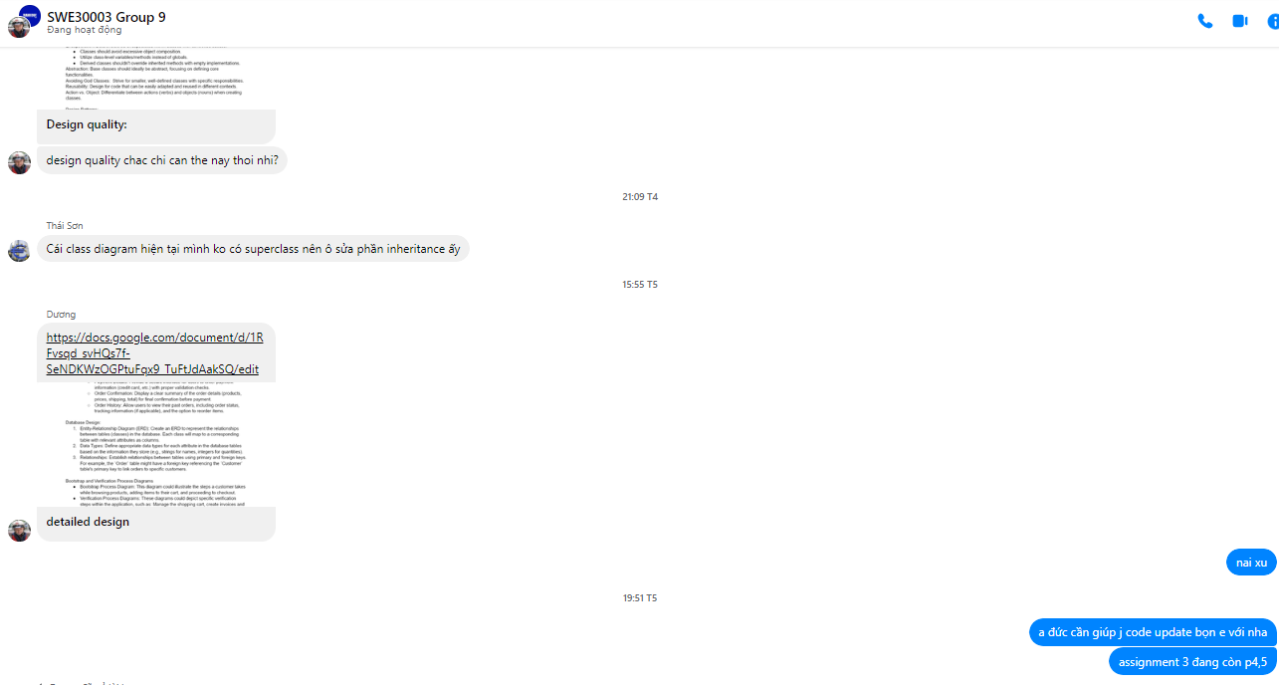

1. **Signed by all members:**

ID Number Name Signature

|  |  |  |
| --- | --- | --- |
| 103803891 | Tran Quoc Dung | QDung |
| 103843282 | Pham Hoang Duong | HDuong |
| 103806531 | Nguyen Thai Son | ThSon |
| 103792724 | Nguyen Manh Duc | ManhDuc |